Project Euler #235 – Pen & Paper Solution

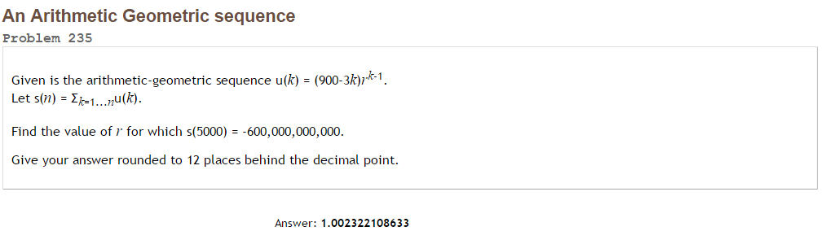



Using wolfram-alpha we get: [1.002322108633](http://www.wolframalpha.com/input/?i=newton+raphson+-4700x%5E5001+%2B4701*x%5E5000+%2B2*10%5E11x%5E2-%284*10%5E11+%2B+300%29x+%2B+%282*10%5E11+%2B+299%29+start+at+1.01+to+13+digits)